FDIC :

The Federal Deposit Insurance Corporation (FDIC) is a crucial entity in the U.S. financial system, established to maintain public confidence and stability in the banking system.

**1. History and Purpose**

The FDIC was created in 1933 in response to the widespread bank failures during the Great Depression. The primary purpose of the FDIC is to insure deposits, thereby protecting depositors from losing their money if a bank fails.

**2. Deposit Insurance**

The FDIC insures deposits in member banks up to the maximum limit set by law, which is currently $250,000 per depositor, per insured bank, for each account ownership category. This insurance covers all types of deposit accounts, including savings, checking, money market deposit accounts, and certificates of deposit (CDs).

**3. Bank Supervision**

The FDIC is responsible for supervising and examining certain financial institutions to ensure they operate safely and soundly and comply with applicable laws and regulations. This oversight helps prevent bank failures and promotes financial stability.

**4. Resolution of Failed Banks**

When a bank fails, the FDIC steps in to manage the process, either by selling the bank to a healthier institution or by paying out insured deposits directly to depositors. The FDIC aims to resolve failed banks in a way that minimizes disruption to customers and the financial system.

**5. Consumer Protection**

The FDIC works to protect consumers by ensuring fair and transparent practices by banks. It provides resources and information to help consumers understand their rights and make informed financial decisions. The FDIC also handles complaints from bank customers and enforces consumer protection laws.

**6. Financial Education and Outreach**

The FDIC engages in various initiatives to promote financial literacy and education among the public. Programs like the Money Smart curriculum aim to help individuals and small businesses improve their financial knowledge and skills.

**7. Research and Analysis**

The FDIC conducts research and analysis on banking and economic trends, providing valuable insights into the health and performance of the financial sector. This information helps shape policies and regulations to enhance financial stability.

**8. Risk Management**

The FDIC assesses risks within the banking system, identifying potential threats to financial stability and working to mitigate them. This proactive approach includes monitoring economic conditions, stress testing banks, and developing contingency plans for potential crises.

**9. FDIC-Insured Institutions**

Banks and savings institutions that are insured by the FDIC must meet certain standards and comply with regulations designed to ensure their soundness and the safety of depositor funds. Being FDIC-insured is a mark of stability and reliability for financial institutions.

**10. Importance of the FDIC**

The FDIC plays a vital role in maintaining confidence in the U.S. banking system. By insuring deposits, supervising banks, and managing bank failures, the FDIC helps ensure that depositors' money is safe and that the banking system remains stable and reliable.

**Conclusion**

The FDIC is an essential institution in the U.S. financial system, providing critical protections for depositors and contributing to the overall stability and confidence in the banking sector. Its comprehensive approach to deposit insurance, bank supervision, consumer protection, and financial education ensures that the U.S. banking system operates efficiently and securely.

250000 dollars

Per FDIC Insured bank

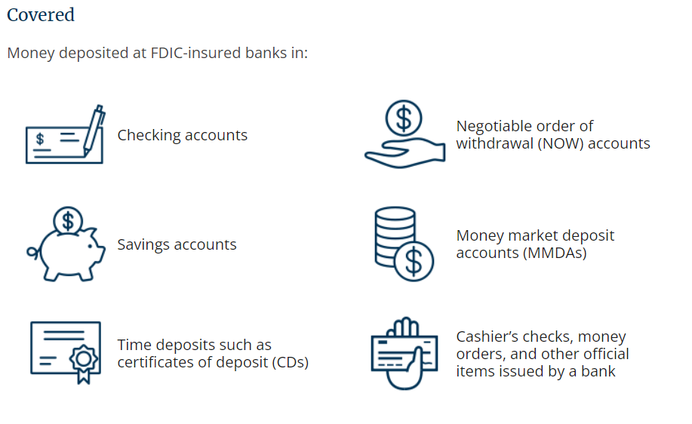

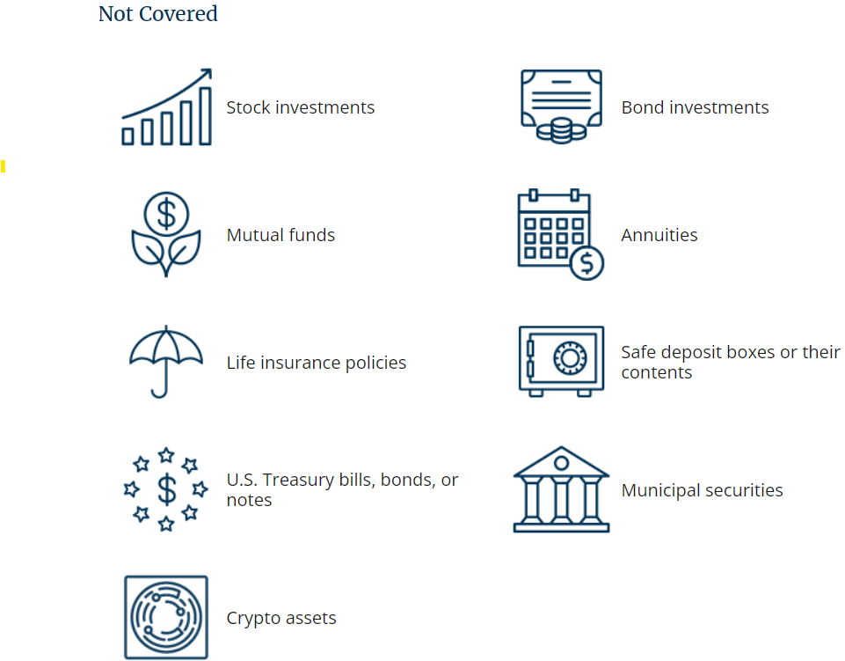

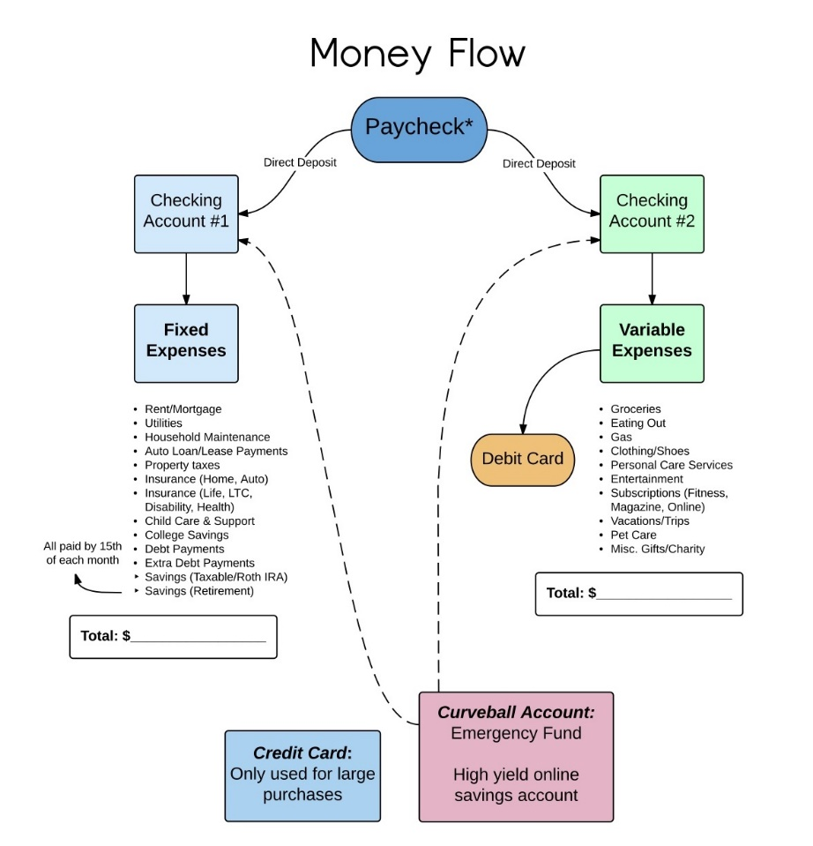

OCC

The Office of the Comptroller of the Currency (OCC) is another key regulatory agency in the U.S. financial system. It plays a crucial role in maintaining the safety, soundness, and fairness of the national banking system.

**1. History and Establishment**

The OCC was established by the National Currency Act of 1863, which was later revised and expanded by the National Bank Act of 1864. The agency was created to oversee the issuance of national bank charters and to regulate and supervise national banks and federal savings associations.

**2. Primary Functions and Responsibilities**

* **Chartering Banks**: The OCC has the authority to grant charters to new national banks and federal savings associations, allowing them to operate under federal supervision.
* **Regulation and Supervision**: The OCC regulates and supervises all national banks and federal savings associations, ensuring they operate safely and soundly, comply with applicable laws and regulations, and serve the needs of their customers and communities.
* **Examinations and Inspections**: The OCC conducts regular examinations and inspections of national banks and federal savings associations to assess their financial health, risk management practices, and compliance with laws and regulations.
* **Enforcement Actions**: When banks or savings associations violate laws or regulations, the OCC has the authority to take enforcement actions. These actions can include fines, restrictions on activities, and, in severe cases, the closure of institutions.
* **Consumer Protection**: The OCC ensures that national banks and federal savings associations adhere to consumer protection laws. It provides resources and support to help consumers understand their rights and resolve complaints.
* **Community Reinvestment Act (CRA) Compliance**: The OCC assesses how well national banks and federal savings associations meet the credit needs of their communities, including low- and moderate-income neighborhoods, under the CRA.

**3. Leadership and Structure**

* The head of the OCC is the Comptroller of the Currency, who is appointed by the President and confirmed by the Senate for a five-year term.
* The OCC operates as an independent bureau within the U.S. Department of the Treasury.
* It is funded primarily by assessments and fees paid by the institutions it regulates, not by taxpayer dollars.

**4. Significance in the Financial System**

* **Maintaining Stability**: By ensuring the safety and soundness of national banks and federal savings associations, the OCC helps maintain the stability of the U.S. financial system.
* **Promoting Fairness**: The OCC enforces consumer protection laws and ensures that financial institutions treat customers fairly and equitably.
* **Supporting Economic Growth**: The OCC supports economic growth by ensuring that banks provide safe and sound credit and other financial services to consumers, businesses, and communities.

**5. Regulatory Framework**

* **Prudential Standards**: The OCC sets prudential standards for capital adequacy, liquidity, risk management, and other key areas to ensure the stability and resilience of national banks and federal savings associations.
* **Regulatory Coordination**: The OCC works closely with other regulatory agencies, such as the Federal Reserve, the Federal Deposit Insurance Corporation (FDIC), and state banking regulators, to ensure a cohesive and effective regulatory framework for the U.S. banking system.

**6. Technology and Innovation**

* The OCC actively monitors and supports technological innovation in the banking sector. It provides guidance on the use of new technologies, such as fintech, blockchain, and digital currencies, to ensure that innovation occurs in a safe and sound manner.

**Conclusion**

The OCC plays a vital role in the U.S. financial system by ensuring the safety, soundness, and fairness of national banks and federal savings associations. Through its regulatory, supervisory, and enforcement functions, the OCC helps maintain financial stability, protect consumers, and support economic growth. Its work is crucial in fostering a robust and resilient banking system that serves the needs of the American public and the broader economy.

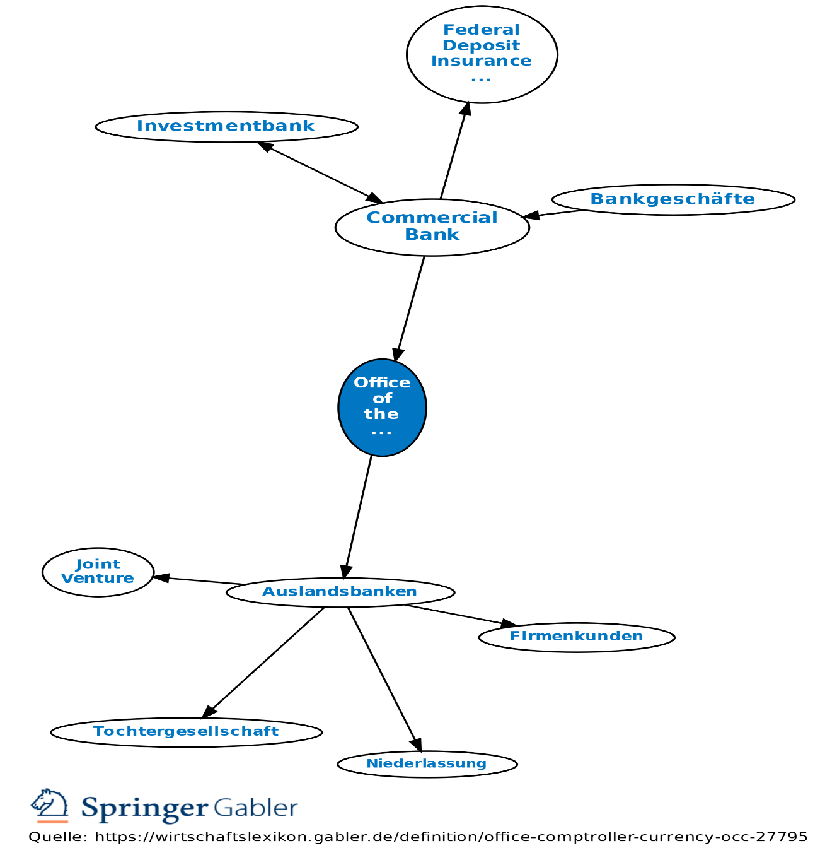

Federal reserve system

The Federal Reserve System, often referred to as "the Fed," is the central bank of the United States. Established to provide the country with a safe, flexible, and stable monetary and financial system, the Fed plays a crucial role in the nation's economy. Here’s a detailed overview of its structure, functions, and significance:

**1. History and Establishment**

The Federal Reserve was created by the Federal Reserve Act of 1913 in response to a series of financial panics, particularly the Panic of 1907, which highlighted the need for central control of the monetary system to alleviate financial crises.

**2. Structure**

The Federal Reserve System has a unique structure composed of several key components:

* **Board of Governors**: Located in Washington, D.C., the Board of Governors consists of seven members appointed by the President and confirmed by the Senate. They serve 14-year terms. The Board is responsible for guiding national monetary policy and overseeing the Federal Reserve Banks.
* **Federal Reserve Banks**: There are 12 regional Federal Reserve Banks, each serving a specific area of the U.S. These banks operate independently but under the supervision of the Board of Governors. They provide services to commercial banks, the U.S. government, and the public.
* **Federal Open Market Committee (FOMC)**: The FOMC is responsible for setting monetary policy, particularly through open market operations. It consists of the Board of Governors, the president of the Federal Reserve Bank of New York, and four other regional Federal Reserve Bank presidents who serve on a rotating basis.
* **Member Banks**: National banks must be members of the Federal Reserve System, while state-chartered banks can choose to join. Member banks hold stock in their regional Federal Reserve Bank and receive dividends.

**3. Functions and Responsibilities**

* **Monetary Policy**: The Fed conducts monetary policy to manage inflation, maximize employment, and stabilize interest rates. It uses tools such as open market operations, the discount rate, and reserve requirements to influence money supply and credit conditions.
* **Supervision and Regulation**: The Federal Reserve supervises and regulates banks and other financial institutions to ensure the safety and soundness of the nation's banking and financial system. This includes conducting regular examinations and enforcing compliance with laws and regulations.
* **Financial Services**: The Fed provides various financial services, including clearing and settling payments, distributing currency and coin, and acting as a banker for the U.S. government. It also plays a central role in the national payments system.
* **Financial Stability**: The Fed monitors and addresses risks to the financial system to prevent and mitigate financial crises. It works with other federal and international authorities to promote financial stability.
* **Consumer Protection and Community Development**: The Fed enforces consumer protection laws, conducts research on consumer issues, and promotes community development by ensuring access to banking services and credit in underserved areas.

**4. Monetary Policy Tools**

* **Open Market Operations (OMO)**: The primary tool used by the FOMC, involving the buying and selling of government securities in the open market to influence the money supply and interest rates.
* **Discount Rate**: The interest rate charged to commercial banks and other depository institutions on loans they receive from their regional Federal Reserve Bank’s lending facility.
* **Reserve Requirements**: The amount of funds that a depository institution must hold in reserve against specified deposit liabilities. Adjusting reserve requirements can influence the money supply.

**5. Significance**

* **Economic Stability**: By managing the money supply and interest rates, the Fed aims to keep inflation in check, promote maximum employment, and ensure moderate long-term interest rates.
* **Banking Supervision**: The Fed's regulatory activities help maintain the health and stability of the banking system, protecting depositors and maintaining confidence in the financial system.
* **Crisis Management**: The Fed acts as a lender of last resort to provide liquidity to banks during times of financial stress, as seen during the 2008 financial crisis and the COVID-19 pandemic.

**6. Recent Developments**

* **COVID-19 Response**: The Fed implemented various emergency measures to support the economy during the COVID-19 pandemic, including slashing interest rates, purchasing large amounts of government and corporate bonds, and providing emergency lending facilities.
* **Technological Innovation**: The Fed is exploring the implications of digital currencies and improving the national payments system through initiatives like the FedNow Service, which aims to provide real-time payments and settlement services.

**Conclusion**

The Federal Reserve System is integral to the stability and efficiency of the U.S. economy. Through its comprehensive approach to monetary policy, banking supervision, financial services, and consumer protection, the Fed plays a pivotal role in fostering a healthy and resilient economic environment.

Top of Form

Bottom of Form